Texarkana Regional History Day
Teacher Registration Instructions
2022-2023

If you cannot get into your teacher account after you register, please contact cnakashian@tamut.edu and we can help you.

Creating a Teacher Account
- Teachers need to register before their students can begin to register. Follow the steps below to begin registration.
- Go to the contest URL: https://tx-trhdc.nhd.org/
- Click Create Account in the toolbar, then select Teacher from the drop-down menu.
- Insert a username (keep it simple, we recommend first and last name with no space), first name, last name, and email address. If I am Not a Robot appears, click the checkbox next to it. Then, click the Save & Continue button.
- You will be asked to confirm your email address by clicking on a link in an email. If necessary, check your spam folder.
- Complete the Teacher’s Profile section.
- Create and Confirm a Password. Then, click the Save & Continue button.
- Choose your school from the dropdown menu. Schools are listed in alphabetical order. If your school is not listed, contact the Regional Coordinator to get it added to the list. Then, click the Save & Continue button.
- Answer the Custom Questions section about your school and its participation. Then, click the Save & Continue button.
- Complete the Teacher’s Permissions and Waivers section (one checkbox and one dropdown response). Then, click the Save & Continue button.
- Registration is complete. Your username will appear on this screen. Record your system username and password.
- You will receive a registration confirmation email from zFairs. Using a school email address may block the registration confirmation email or mark it as spam.

Logging into Teacher Account (After Registering)
- Go to the contest URL: https://tx-trhdc.nhd.org/
- Click Login in the top right corner.
- Insert your username and password.
  - If you forgot your username and/or password, click the blue Help hyperlink and follow the prompts to reset.

Logging Out of Teacher Account
- Click your name in the top right corner.
- Select Logout from the drop-down menu.

Editing Teacher Account Information
- After logging in to your teacher account, click your name in the top right corner.
- Select My Profile from the drop-down menu to edit your personal information before registration ends.
- Select Change Password to change the password for your account.

Checking Your Students’ Registration Progress
- After logging in to your teacher account, click My Students in the top toolbar.
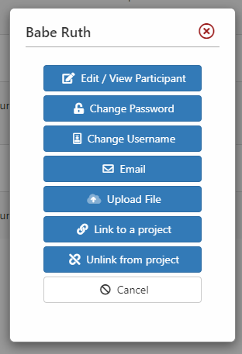
- This page lists each of your students. Click on a name to bring up a pop-up menu. You can Edit/View Participant profiles, change Passwords or Usernames, Link/Unlink Projects, and Email Participants. This is optional and can only be done before contest registration closes.

